Aliza Rashid
Student ID: CA/SE1/5303
Cyber Security Intern

Task 1: Basic Network Sniffer
1. Introduction
Network security is a crucial aspect of cybersecurity. Understanding how data flows across a network helps in detecting malicious activities and securing systems. A network sniffer is a tool used to capture and analyze network packets in real time. This task focuses on building a basic network sniffer using Python to capture and analyze network traffic.

2. Objective
The main objectives of this task are:
- To capture live network packets from the network
- To analyze packet structure and contents
- To understand how different network protocols work
- To display useful information such as source IP, destination IP, protocol type, and payload

3. Tools and Technologies Used
- Programming Language: Python 3.11
- Library: Scapy
- Operating System: Windows
- Tool: Windows PowerShell (Administrator mode)
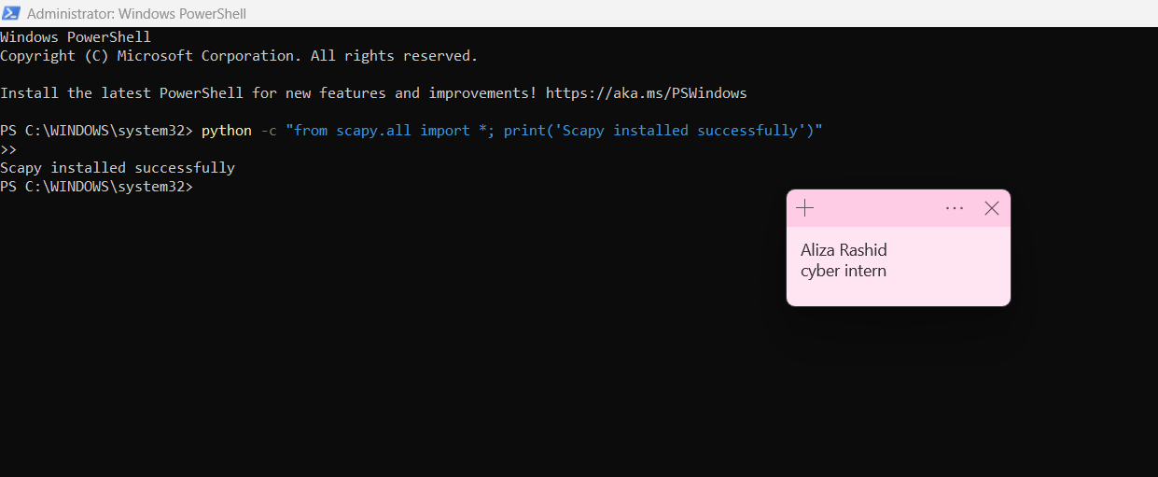

4. Methodology
The network sniffer was implemented using the Scapy library in Python. Scapy provides powerful packet manipulation and sniffing capabilities.
The program captures packets using the sniff() function. Each captured packet is passed to a handler function where the packet is analyzed. The program checks if the packet contains an IP layer and then extracts relevant information such as:
- Source IP address
- Destination IP address
- Transport layer protocol (TCP, UDP, ICMP)
- Source and destination port numbers
- Payload data (if available)
The packet details are printed on the console in real time.
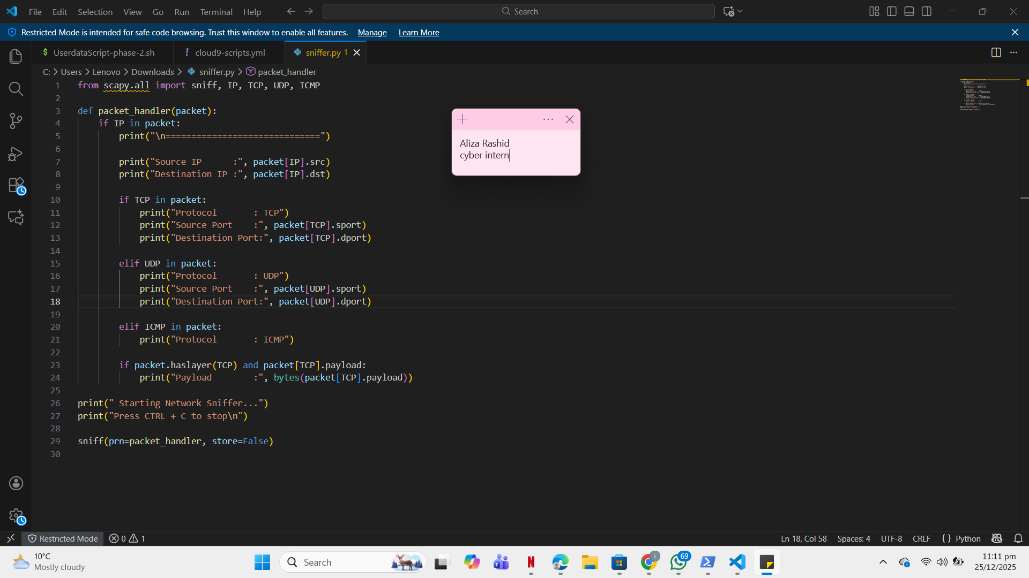

5. Packet Analysis
The following protocols were observed during packet capture:
5.1 TCP (Transmission Control Protocol)
- Used for reliable communication
- Commonly seen in web traffic (HTTP/HTTPS)
- Provides source and destination port numbers
5.2 UDP (User Datagram Protocol)
- Connectionless and faster than TCP
- Used in DNS and streaming services
5.3 ICMP (Internet Control Message Protocol)
- Used for network diagnostics
- Commonly observed during ping requests

6. Output
During execution, the program displayed live packet details including source IP, destination IP, protocol type, ports, and payload. This confirmed that the sniffer was successfully capturing and analyzing network traffic.
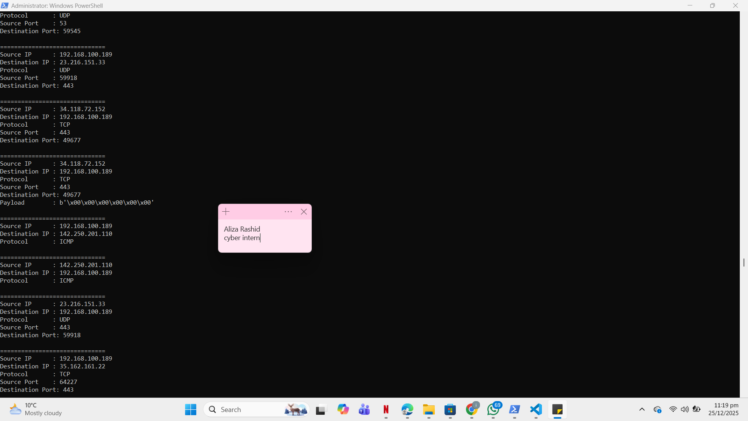
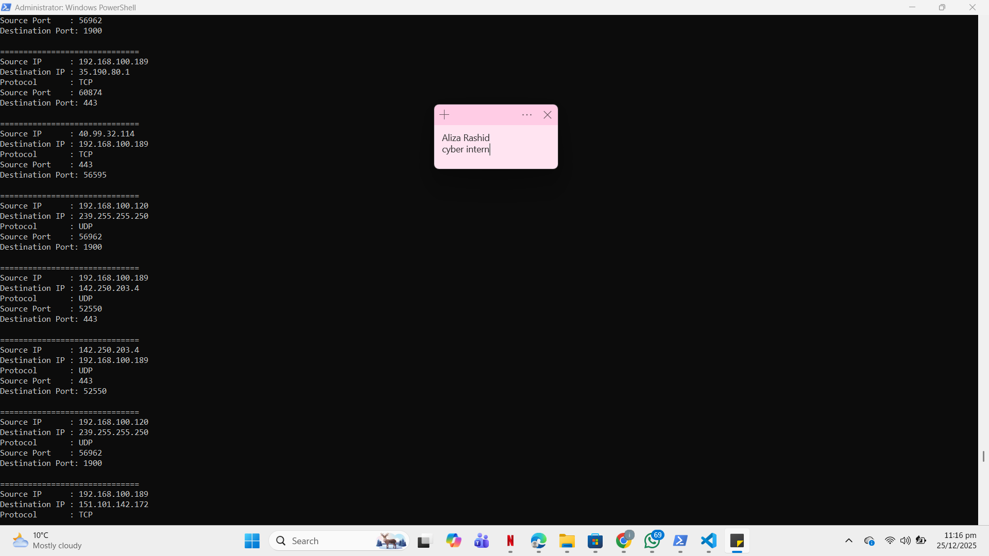
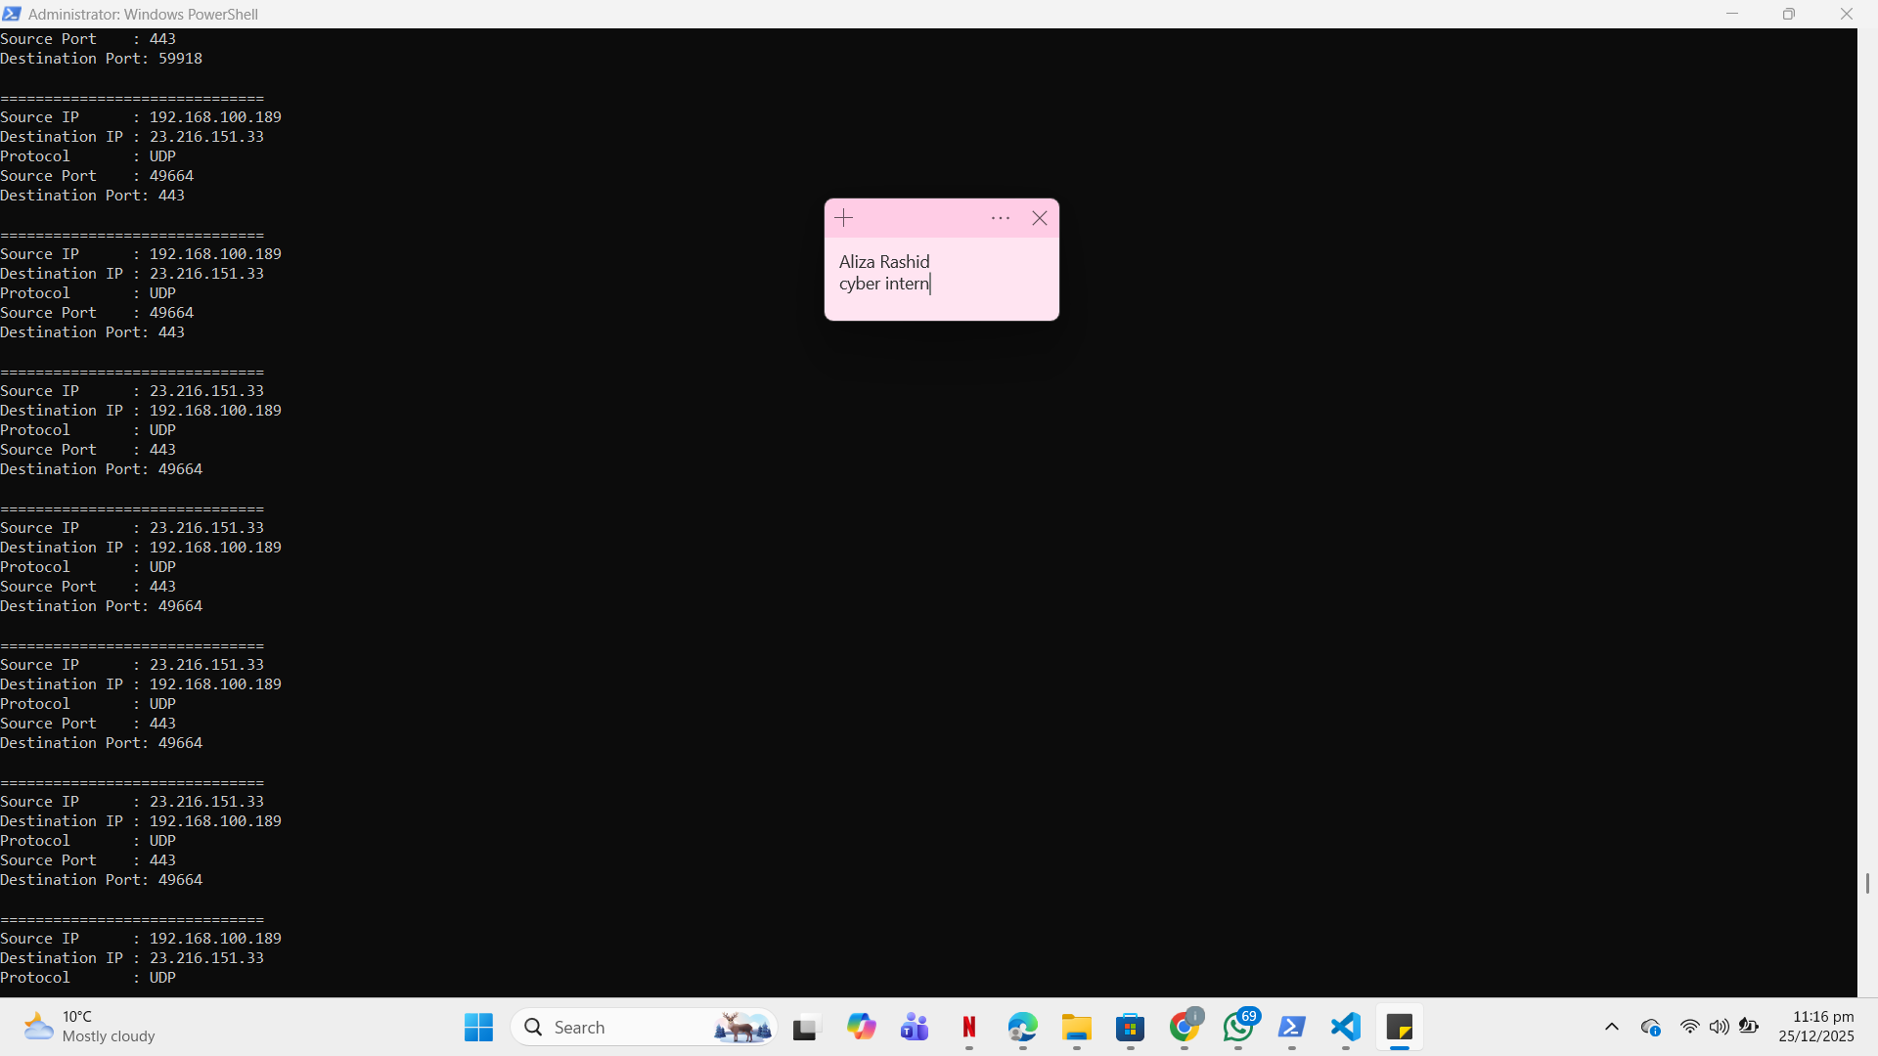
After this we opened other windows PowerShell and run it as administrator and run command
PS C:\WINDOWS\system32> ping google.com
And got these results
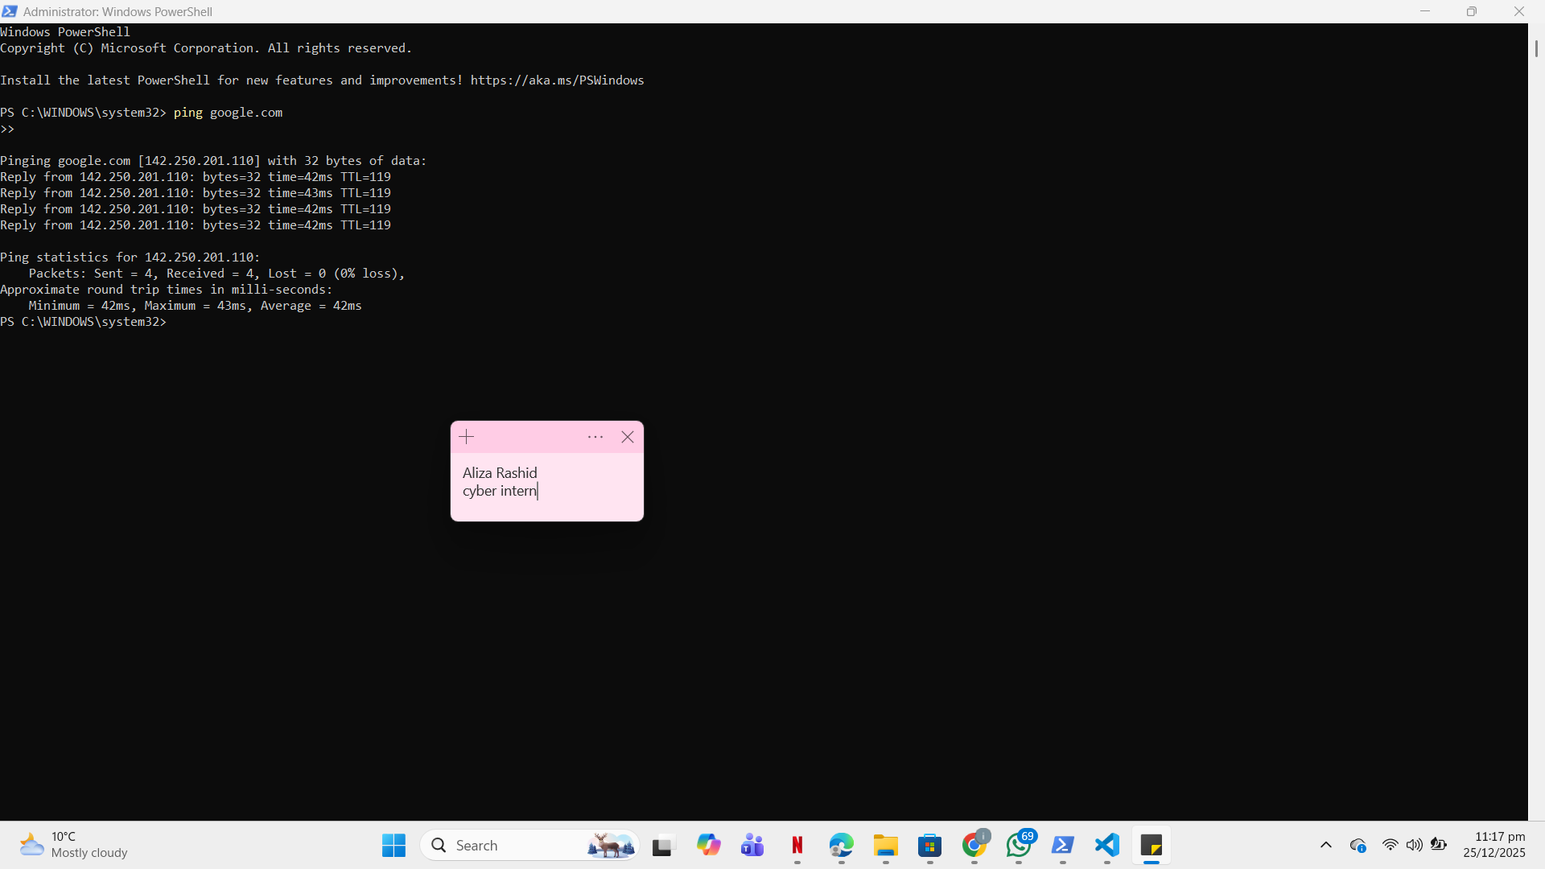
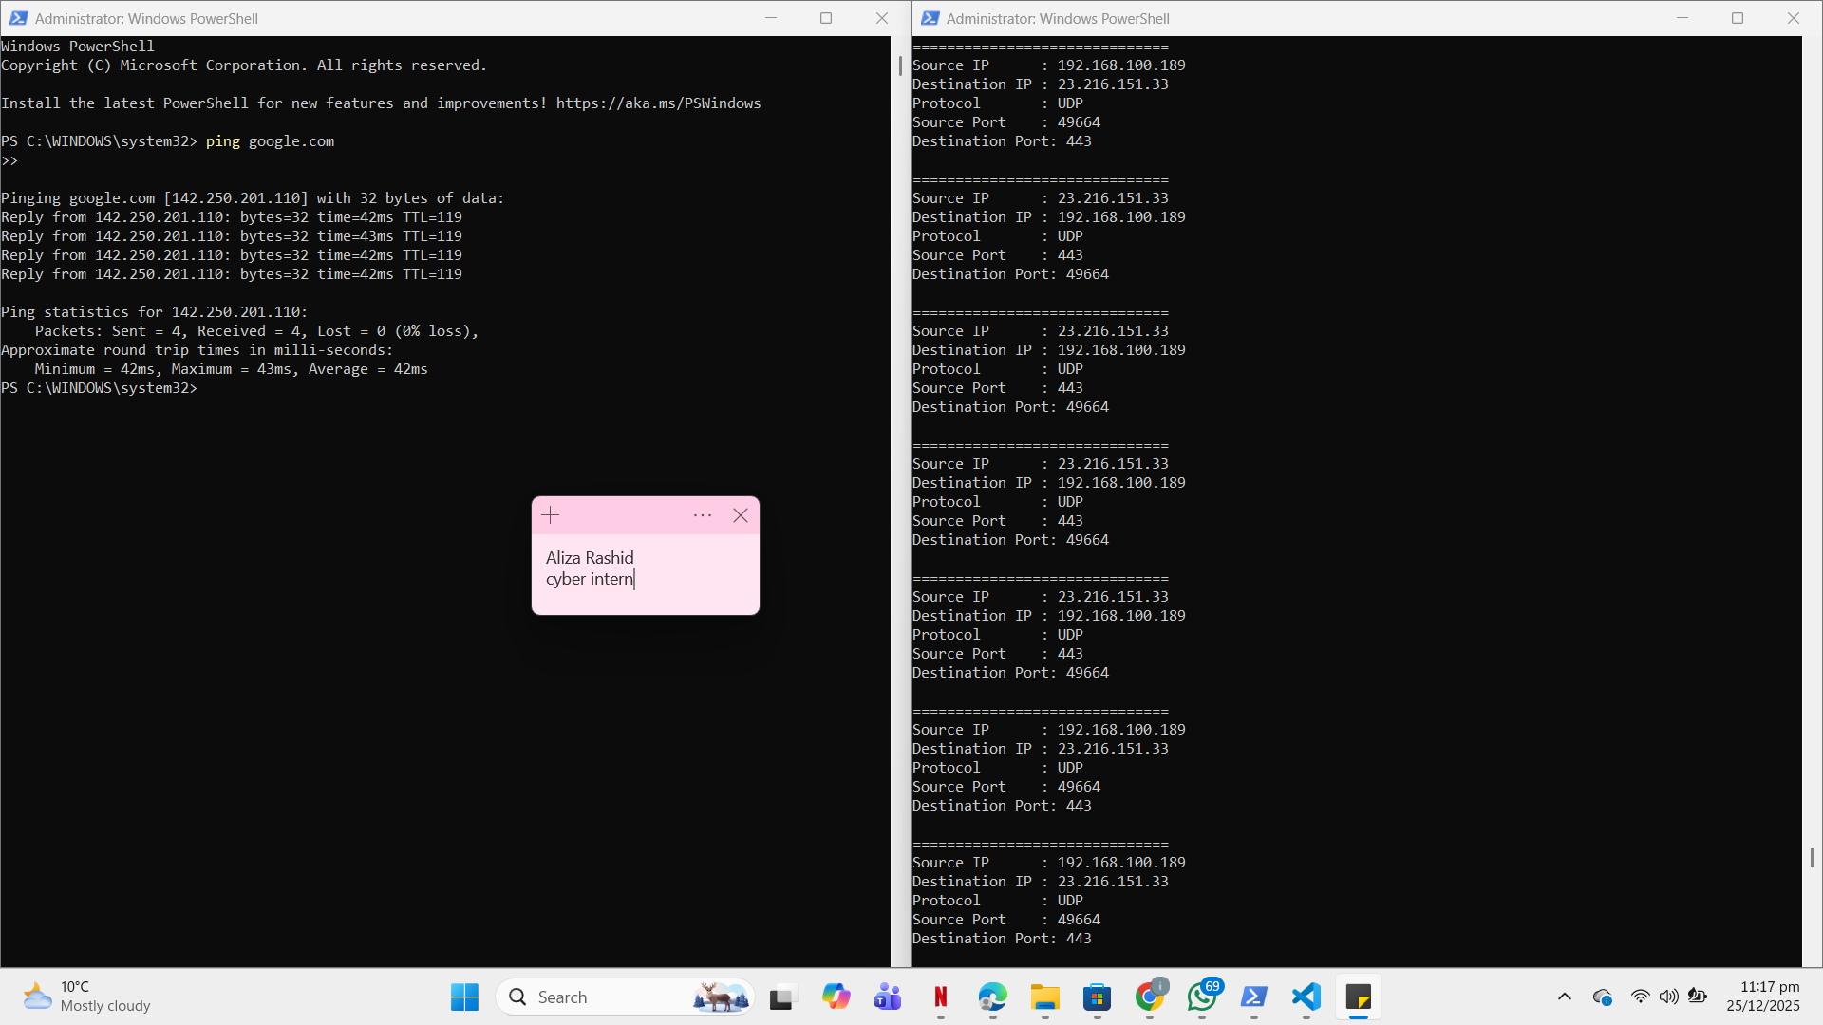

7. Results
The network sniffer successfully captured live network packets and displayed meaningful information. By generating traffic through web browsing and ping commands, various protocols such as TCP and ICMP were observed. The task helped in understanding real-time data flow within a network.

8. Conclusion
This task provided practical exposure to network traffic analysis using Python. Building a basic network sniffer enhanced understanding of packet structures, network protocols, and data flow across networks. Such tools play an important role in network monitoring and cybersecurity.

9. Future Enhancements
- Apply filters to capture specific protocols only
- Save captured packets to a file for offline analysis
- Improve output formatting for better readability
- Add logging functionality

